Ideation Phase

Empathize & Discover

Date | 2 November 2025
Team ID | NM2025TMID00585
Project Name | Laptop Request Catalogue Items
Maximum Marks | 4 Marks

Empathy Map Canvas:

In the Empathize & Discover phase, the team observed how employees and managers handle laptop requests within the organization. Many users expressed frustration due to slow approvals, unclear catalog options, and lack of real-time status updates. Manual approval processes often led to delays, repeated follow-ups, and miscommunication between departments. Through interviews with employees and department heads, the team identified key challenges such as difficulty comparing laptop models, confusing request forms, poor visibility of approval progress, and limited feedback and tracking. These findings revealed the need for a transparent and automated Laptop Request Catalogue System to simplify and accelerate the process.
By empathizing with the users’ daily struggles, the team gained insights into the emotional and practical barriers that reduced efficiency. This understanding became the foundation for designing a user-friendly and efficient system that ensures smooth communication, quick approvals, and clear information flow.

Example: Empathy Map for Laptop Request System

Think & Feel | “Why is my laptop request taking so long?” “I’m not sure if my reque approve
See | Confusing catalog layout, outdated model list, manual approval chain
Hear | “You need to send a reminder.” “Your approval is still pending.”
Say & Do | Sends multiple reminder emails, contacts admin frequently, checks
Pain | Slow approvals, unclear process, manual errors
Gain | Faster approvals, clarity, satisfaction, digital tracking

Empathy Map Summary
By empathizing with employees’ frustrations, the team identified the critical issues that impacted workflow efficiency. Users wanted a simpler, transparent, and faster process to request laptops
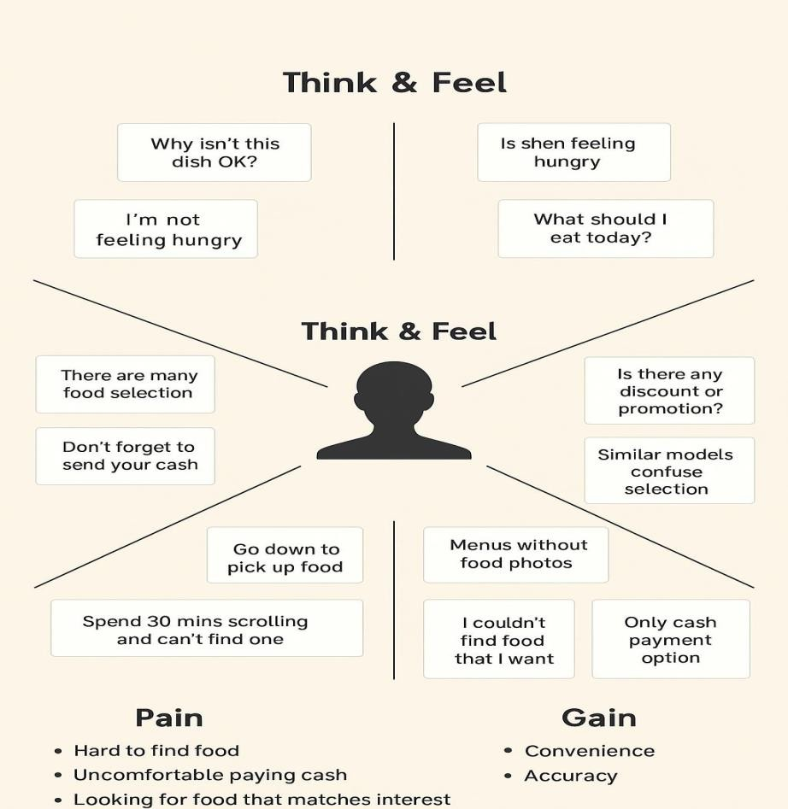

without confusion or delays. The proposed system aims to solve these problems by introducing a centralized digital catalog for all laptop models, automated approval routing to minimize delays, a real-time tracking dashboard for employees and managers, and clear notifications and reminders for each approval stage. These solutions will create a smoother and more transparent experience, improving user satisfaction and reducing administrative workload.
From the “Think & Feel” quadrant, it becomes evident that users want reassurance that their request is being processed efficiently. The “Say & Do” quadrant reveals their actions—submitting requests, checking for updates, and contacting the helpdesk for confirmation. The “Pain” section highlights major issues like approval delays, system errors, and lack of communication. On the other hand, the “Gain” section shows that users appreciate features like faster response, proper notifications, and a simple, user-friendly interface.
Reference: https://www.mural.co/templates/empathy-map-canvas

Example: Food Ordering & Delivery Application

Think & Feel | “What should I eat?” “Delivery is slow.”
See | Limited menu options, delayed delivery updates
Hear | “Your order is on the way.”
Say & Do | Rechecks order status, tries multiple restaurants
Pain | Long delivery time, confusion, missing items
Gain | Comfort, quick service, reliability

By comparing this with the Laptop Request System, similar pain points were found—lack of clarity, delayed responses, and communication gaps. Applying empathy helped redesign the laptop request process into a digitally optimized system that meets both user needs and organizational goals.

